Database System Lab Project:
Student Management System

Mahnoor Nadeem(f2024266254)
Eshal Nabeeha Khan(f20242661093)
Course: Database Systems Lab
Instructor: Awais Amin
Section: V9

Requirement Analysis
Overview
The School Management System (SMS) is a relational database application designed to enable efficient management of students, teachers, courses, class schedules, attendance, examinations, and academic results.
Functional Requirements:
- Maintain detailed records of students, teachers, and courses
- Assign teachers to courses and organize classes with scheduling details
- Track student enrollment in courses with enrollment status
- Record and query daily attendance for each student per course
- Manage examination schedules and types (quiz, midterm, final)
- Store and analyze student results and grades
Non-Functional Requirements:
- Data integrity enforced through primary and foreign key constraints
- Default values for status fields (e.g., student status = 'Active', enrollment = 'Enrolled')
- NOT NULL constraints on critical fields such as student name, course name, exam date
- UNIQUE constraints on course codes and student emails
- Scalable schema to support multiple classes, sections, and departments

Entity | Description | Key Attributes
Courses | Academic courses offered by the institution | Course_ID, Course_Name, Course_Code, Credit_Hours
Teacher | Faculty members who deliver courses | Teacher_ID, Name, Qualification, Department, Salary
Teacher_Course | Maps teachers to the courses they teach | TC_ID, Teacher_ID, Course_ID
Class | A scheduled session with room and timing info | Class_ID, Class_Name, Section, Room_No, Timings
Student | Enrolled students with personal information | Student_ID, Name, Email, Gender, DOB, Class_ID
Enrollment | Tracks which student is enrolled in which course | Enrollment_ID, Date, Status, TC_ID, Student_ID
Attendance | Daily attendance record per student per course | Attendance_ID, Date, Status, TC_ID, Student_ID
Exams | Examination events linked to a course | Exam_ID, Date, Description, Total_Marks, TC_ID
Results | Marks and grades obtained by students in exams | Result_ID, Marks_Obtained, Grade, Exam_ID, Student_ID

Entity-Attribute Details

ER Diagram
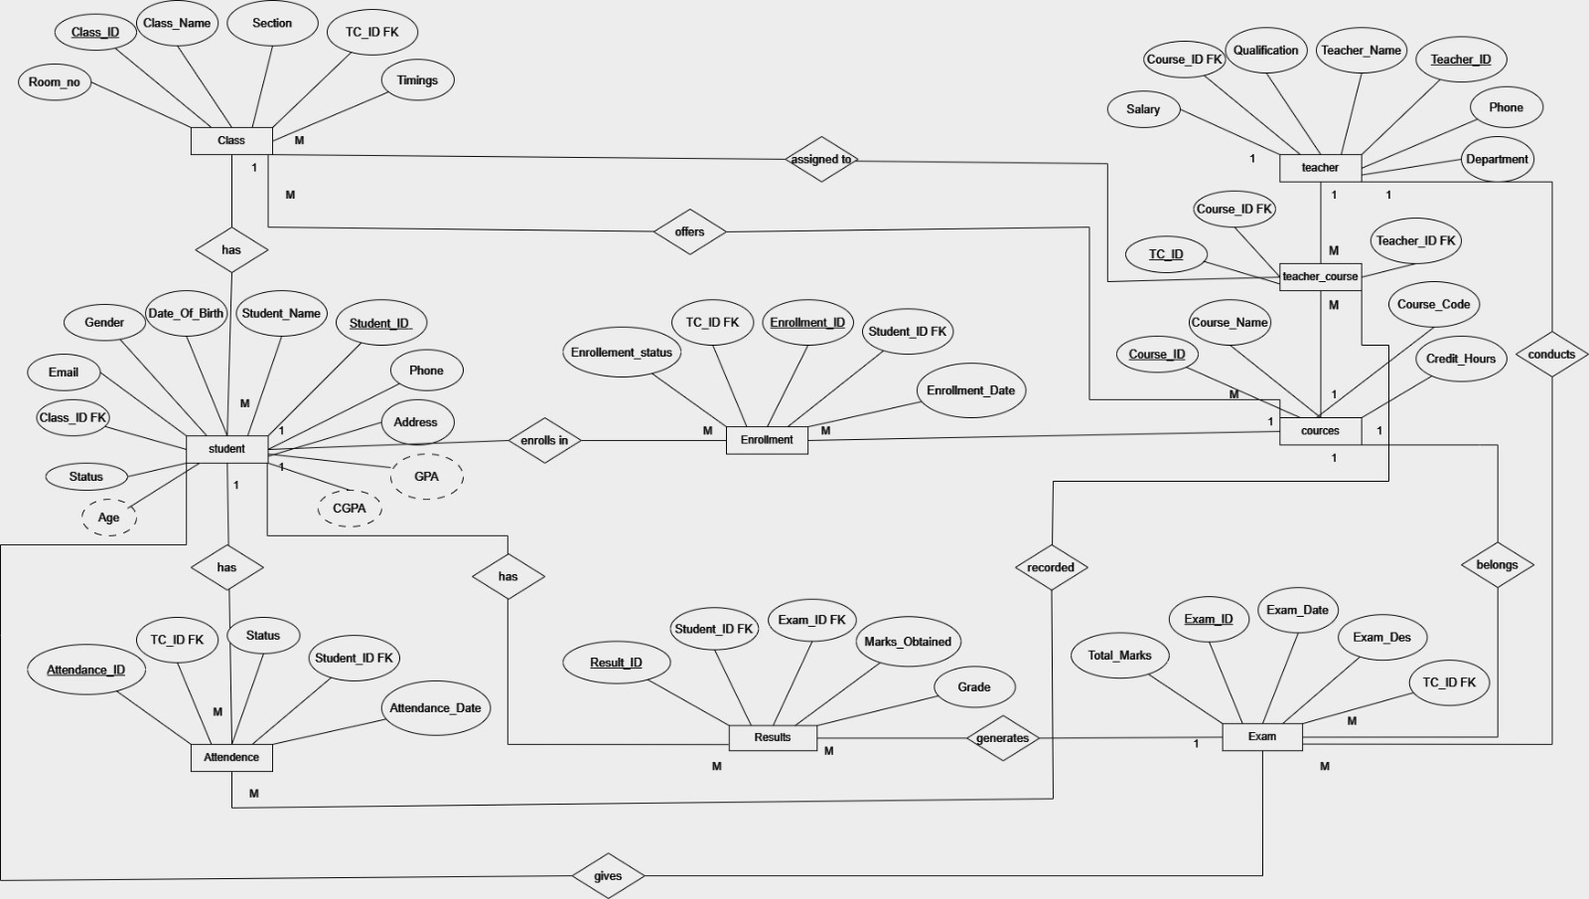

Entity Relationships
Relationship | Cardinality | Description
Teacher → Teacher_Course | 1 : Many | One teacher can be assigned to multiple courses
Course → Teacher_Course | 1 : Many | One course can be taught by a teacher (via TC)
Teacher_Course → Class | 1 : Many | One TC assignment can have multiple class sections
Class → Student | 1 : Many | One class can have many students enrolled in it
Teacher_Course → Enrollment | 1 : Many | Enrollments are linked to a teacher-course pairing
Student → Enrollment | 1 : Many | One student can have multiple enrollments
Teacher_Course → Attendance | 1 : Many | Attendance is recorded per TC assignment
Student → Attendance | 1 : Many | A student can have many attendance records
Teacher_Course → Exams | 1 : Many | Exams belong to a teacher-course assignment
Exam → Results | 1 : Many | One exam can have results for many students
Student → Results | 1 : Many | A student can have results across multiple exams

courses | Course_ID (PK), Course_Name, Course_Code (UNIQUE), Credit_Hours
Relational Schema
teacher | Teacher_ID (PK), Teacher_Name, Qualification, Department, Phone, Salary

teacher_course | TC_ID (PK), Teacher_ID (FK → teacher), Course_ID (FK → courses)
class | Class_ID (PK), Class_Name, Section, Room_No, Timings, TC_ID (FK → teacher_course)

student | Student_ID (PK), Student_Name, Email, Phone, Address, Gender, Status, Date_of_Birth, Class_ID (FK → class)

enrollment | Enrollment_ID (PK), Enrollment_Date, Enrollment_Status, TC_ID (FK → teacher_course), Student_ID (FK → student)
attendance | Attendance_ID (PK), Attendance_Date, Status, TC_ID (FK → teacher_course), Student_ID (FK → student)

exams | Exam_ID (PK), Exam_Date, Exam_Des, Total_Marks, TC_ID (FK → teacher_course)

results | Result_ID (PK), Marks_Obtained, Grade, Exam_ID (FK → exams), Student_ID (FK → student)

Database Implementation ( DDL)
DROP TABLE IF EXISTS results;
DROP TABLE IF EXISTS attendance;
DROP TABLE IF EXISTS exams;
DROP TABLE IF EXISTS enrollment;
DROP TABLE IF EXISTS student;
DROP TABLE IF EXISTS class;
DROP TABLE IF EXISTS teacher_course;
DROP TABLE IF EXISTS teacher;
DROP TABLE IF EXISTS courses;

USE master;
GO
IF NOT EXISTS (SELECT name FROM sys.databases WHERE name = 'project')
CREATE DATABASE project;
GO
USE project;
GO

create database project;

create table courses(
Course_ID int primary key,
Course_Name varchar(100) not null,
Course_Code varchar(20) unique not null,
Credit_Hours int
);

create table teacher(
Teacher_ID int primary key,
Teacher_Name varchar(100) not null,
Qualification varchar(100),
Department varchar(100),
Phone varchar(11),
Salary float
);

create table teacher_course(
TC_ID int primary key,
Teacher_ID int foreign key references teacher(Teacher_ID),
Course_ID int foreign key references Courses(Course_ID)
);

create table class(
Class_ID int primary key,
Class_Name varchar(50),
Section varchar(10),
Room_No varchar(20),
Timings varchar(50),
TC_ID int foreign key references teacher_course(TC_ID)
);

create table student(
Student_ID int primary key,
student_Name varchar(100) not null,
Email varchar(50),
Phone varchar(11),
Address varchar(100),
Gender varchar(50),
status varchar(50) default 'active',
Date_of_Birth date,
Class_ID int foreign key references class(Class_ID)
);

create table enrollment(
Enrollment_ID int primary key,
Enrollment_Date date,
Enrollment_Status varchar(50) default 'active',
TC_ID int foreign key references teacher_course(TC_ID),
Student_ID int foreign key references student(Student_ID)
);

create table attendance(
Attendance_ID int primary key,
Attendance_Date date not null,
Status varchar(50) default 'present',
TC_ID int foreign key references teacher_course(TC_ID),
Student_ID int foreign key references student(Student_ID)
);

create table exams(
Exam_ID int primary key,
Exam_Date date not null,
Exam_Des varchar(50) not null,
Total_marks int not null,
TC_ID int foreign key references teacher_course(TC_ID)
);

create table results(
Result_ID int primary key,
Marks_Obtained int not null,
Grade varchar(10),
Exam_ID int foreign key references exams(Exam_ID),
Student_ID int foreign key references student(Student_ID)
);

Database Implementation ( DML)
--INSERT VALUES
--courses
INSERT INTO courses VALUES (1, 'Database Systems', 'CS-301', 3);
INSERT INTO courses VALUES (2, 'Computer Networks', 'CS-401', 2);
INSERT INTO courses VALUES (3, 'Computer Architecture', 'CS-302', 3);
INSERT INTO courses VALUES (4, 'Data Structures', 'CS-303', 3);
INSERT INTO courses VALUES (5, 'Linear Algebra', 'CS-201', 3);
--teacher
INSERT INTO teacher VALUES (1, 'Dr. Muhammad Husnain Ashfaq', 'PhD Computer Science', 'SST', '03001234567', 120000);
INSERT INTO teacher VALUES (2, 'Ms. Jawaria Amir', 'MS Software Engineering', 'SST', '03111234567', 90000);
INSERT INTO teacher VALUES (3, 'Mr.Nouman Saleem', 'MS Networks', 'SST', '03221234567', 100000);
INSERT INTO teacher VALUES (4, 'Dr. Sidra Khalid', 'PhD Quantam Physics', 'SST', '03331234567', 115000);
INSERT INTO teacher VALUES (5, 'Ms. Yasmin Khatoon', 'MS English Language', 'SLA', '03441234567', 80000);
--teachercourse
INSERT INTO teacher_course VALUES (1, 1, 1);
INSERT INTO teacher_course VALUES (2, 3, 2);
INSERT INTO teacher_course VALUES (3, 2, 3);
INSERT INTO teacher_course VALUES (4, 4, 4);
INSERT INTO teacher_course VALUES (5, 5, 5);
--class
INSERT INTO class VALUES (1, 'BS CS', 'A', 'R-101', '08:00-09:15', 1);
INSERT INTO class VALUES (2, 'BS CS', 'B', 'R-102', '09:30-10:45', 2);
INSERT INTO class VALUES (3, 'BS SE', 'A', 'R-201', '11:00-12:15', 3);
INSERT INTO class VALUES (4, 'BS SE', 'C', 'R-103', '12:30-01:45', 4);
INSERT INTO class VALUES (5, 'BS IT', 'A', 'R-301', '02:00-03:30', 5);

--student
INSERT INTO student VALUES (1, 'Eshal Nabeeha Khan', 'f20242661093@umt.edu.pk', '03501234567', 'Lahore', 'Female', 'Active', '2006-03-07', 1);
INSERT INTO student VALUES (2, 'Mahnoor Nadeem', 'f2024266254@umt.edu.pk', '03601234567', 'Lahore', 'Female', 'Active', '2006-09-18', 1);
INSERT INTO student VALUES (3, 'Rayyan Ijaz', 'f2024266301@umt.edu.pk', '03701234567', 'Faisalabad', 'Male', 'Active', '2005-01-15', 2);
INSERT INTO student VALUES (4, 'Zoya', 'f2024266312@umt.edu.pk', '03801234567', 'Multan', 'Female', 'Active', '2005-11-30', 3);
INSERT INTO student VALUES (5, 'Hadi Mubeen', 'f2024266325@umt.edu.pk', '03901234567', 'Lahore', 'Male', 'Active', '2005-03-18', 4);
INSERT INTO student VALUES (6, 'Areeb Masood', 'f2024266338@umt.edu.pk', '03011234567', 'Lahore', 'Female', 'Active', '2005-06-05', 5);
INSERT INTO student VALUES (7, 'Abdul Munib Mushtaq', 'f2024266347@umt.edu.pk', '03121234567', 'Sialkot', 'Male', 'Active', '2005-09-12', 2);
INSERT INTO student VALUES (8, 'Faakhir Waqar', 'f2024266359@umt.edu.pk', '03211234567', 'Lahore', 'Male', 'Active', '2005-07-22', 3);
INSERT INTO student VALUES (9, 'Khawaja Muhammad Bilal', 'f2024266372@umt.edu.pk', '03311234567', 'Lahore', 'Male', 'Active', '2005-04-10', 4);
INSERT INTO student VALUES (10, 'Farkhanda Noor', 'f2024266385@umt.edu.pk', '03411234567', 'Lahore', 'Female', 'Active', '2006-08-14', 5);

--enrollment
INSERT INTO enrollment VALUES (1, '2024-09-01', 'Enrolled', 1, 1);
INSERT INTO enrollment VALUES (2, '2024-09-01', 'Enrolled', 1, 2);
INSERT INTO enrollment VALUES (3, '2024-09-02', 'Dropped', 2, 3);
INSERT INTO enrollment VALUES (4, '2024-09-02', 'Enrolled', 3, 4);
INSERT INTO enrollment VALUES (5, '2024-09-03', 'Enrolled', 4, 5);
INSERT INTO enrollment VALUES (6, '2024-09-03', 'Enrolled', 5, 6);
INSERT INTO enrollment VALUES (7, '2024-09-04', 'Dropped', 2, 7);
--attendance
INSERT INTO attendance VALUES (1, '2024-09-10', 'Present', 1, 1);
INSERT INTO attendance VALUES (2, '2024-09-10', 'Present', 1, 2);
INSERT INTO attendance VALUES (3, '2024-09-10', 'Absent', 2, 3);
INSERT INTO attendance VALUES (4, '2024-09-11', 'Present', 3, 4);
INSERT INTO attendance VALUES (5, '2024-09-11', 'Late', 4, 5);
INSERT INTO attendance VALUES (6, '2024-09-11', 'Present', 5, 6);
INSERT INTO attendance VALUES (7, '2024-09-12', 'Absent', 2, 7);
--exams
INSERT INTO exams VALUES (1, '2024-11-10', 'Midterm', 50, 1);
INSERT INTO exams VALUES (2, '2024-11-11', 'Midterm', 50, 2);
INSERT INTO exams VALUES (3, '2024-11-12', 'Midterm', 50, 3);
INSERT INTO exams VALUES (4, '2024-11-13', 'Quiz', 20, 4);
INSERT INTO exams VALUES (5, '2024-11-14', 'Final', 100, 5);
--results
INSERT INTO results VALUES (1, 45, 'A+', 1, 1);
INSERT INTO results VALUES (2, 42, 'B', 1, 2);
INSERT INTO results VALUES (4, 30, 'C+', 3, 4);
INSERT INTO results VALUES (5, 18, 'A', 4, 5);
INSERT INTO results VALUES (6, 88, 'A+', 5, 6);
INSERT INTO results VALUES (7, 22, 'B', 2, 7);

SQL Queries
select * from student;
select * from courses;
select * from teacher;
select * from attendance;
select * from teacher_course;
select * from exams;
select * from results;

--shows students and their respective clas sections;
select s.Student_ID , s.student_Name ,c.Section
from student s
join class c
on s.Class_ID = c.Class_ID;

-- Show each teacher with the course they teach
select t.Teacher_Name, co.Course_Name, co.Course_Code
from teacher t
join teacher_course tc ON t.Teacher_ID = tc.Teacher_ID
join courses co ON tc.Course_ID = co.Course_ID;

--Get attendance summary of student
select s.student_Name, a.Status, count(*) AS Total
from attendance a
join student s ON a.Student_ID = s.Student_ID
group by s.student_Name, a.Status
order by s.student_Name;

--Show all enrolled students with their course name and enrollment status
select s.student_Name, co.Course_Name, e.Enrollment_Status, e.Enrollment_Date
from enrollment e
join student s ON e.Student_ID = s.Student_ID
join teacher_course tc ON e.TC_ID = tc.TC_ID
join courses co ON tc.Course_ID = co.Course_ID;

-- Display exam results with student name, exam type, marks, and grade
select s.student_Name, ex.Exam_Des, ex.Total_marks, r.Marks_Obtained, r.Grade
from results r
join student s ON r.Student_ID = s.Student_ID
join exams ex ON r.Exam_ID = ex.Exam_ID
order by ex.Exam_Des;

-- Find students who have dropped any course
SELECT s.student_Name, co.Course_Name, e.Enrollment_Date
FROM enrollment e
JOIN student s ON e.Student_ID = s.Student_ID
JOIN teacher_course tc ON e.TC_ID = tc.TC_ID
JOIN courses co ON tc.Course_ID = co.Course_ID
WHERE e.Enrollment_Status = 'Dropped';

--List teachers with salary above average
SELECT Teacher_Name, Department, Qualification, Salary
FROM teacher
WHERE Salary > (SELECT AVG(Salary) FROM teacher)
ORDER BY Salary DESC;

-- Show students who were absent at least once
SELECT DISTINCT s.student_Name, s.Email, s.Phone
FROM attendance a
JOIN student s ON a.Student_ID = s.Student_ID
WHERE a.Status = 'Absent';

--Display full class scheduleclass, room, timing, teacher, and course
SELECT c.Class_Name, c.Section, c.Room_No, c.Timings,
t.Teacher_Name, co.Course_Name
FROM class c
JOIN teacher_course tc ON c.TC_ID = tc.TC_ID
JOIN teacher t ON tc.Teacher_ID = t.Teacher_ID
JOIN courses co ON tc.Course_ID = co.Course_ID
ORDER BY c.Class_Name;

-- shows age of students
select student_Name, Date_of_Birth,
2026-year(Date_of_Birth) AS Age
from student;

